Master of Science in Applied Artificial Intelligence (MS-AAI) Self-assessment Questions

A Note to Prospective Students in Artificial Intelligence:
Hello! Welcome, and congratulations on taking your first step toward this fast-paced and rewarding field. This self-assessment is designed to help you identify your level of preparedness for the Master of Science in Applied Artificial Intelligence Program at USD. You will be able to get a good sense of your basic technical background and time management by completing this test. You should aim to answer all the questions in the assessment offline with limited effort in 1-4 hours.
The purpose of this self-assessment is only to highlight specific areas that may require extra preparation before beginning the program. Please do not be discouraged if you are unable to answer all the questions; this only indicates that you need to refresh and prepare those concepts and topics further. Additional information is embedded throughout the document, and we strongly encourage you to take advantage of the free resources on the Internet.
We wish you good luck!

General Math
- $\log_{2}$ (8) = x What is x?

- Write ${15}^{3/4}=8$ in logarithmic form.

More information on logarithms here.

- How many permutations can you make from the letters d,e,f?

- How many permutations can you make from the letters a,b,c,d,e,f?

- An ice cream parlor offers ten different toppings for their sundaes. How many different 3-topping sundae combinations (not allowing for double toppings) are there?

More information on permutations here.

- If A = {3,4,5,6,7} and B = {2,3,4,5,6,7,8}, what is $A∩B$ and $A∪B$?

More information on sets here.

- What is the slope of the line that includes the points (-2, 2) and (-4, 8)?

More information on slopes here.

- True or False, $a^{0}=1$?

More information on the Zero Power Rule and exponents here.

- Simplify using the quotient rule $\frac{x^{4}}{x^{9}}=$?

More information on the Quotient Rule for Exponents here.

Calculus
- For x≠4, differentiate f(x)= $\frac{x^{2}}{4-x}$

More information on basic differentiation here.

- Evaluate $\frac{\lim_{x→8}{2x^{2}-17x+8}}{8-x}$

More information on limits here.

- Find the derivative of $f\left(y\right)\frac{4y^{3}-7y+8}{y}$

More information on derivative concepts here.

- Evaluate the following indefinite integral with respect to $x$: $∫6x^{5}ⅆx-12x^{2}+8$

More information on indefinite integrals here.

Probability
- If a fair coin was flipped 3 times and it landed on heads twice. What is the probability of this happening?

For more information, please review here.

- 60% of swimmers do not wear goggles nor a swim cap. 20% wear goggles, and 30% wear swim caps. If one swimmer is chosen at random, what is the probability that he/she is wearing both goggles and a swim cap? It may be helpful to draw a Venn Diagram to visualize.

More information on probability, intersection, and union of sets here.

- If one card is drawn from a standard 52 card deck, what is the probability it will be a red (hearts or diamonds) face card (king, queen, or jack?)

For more information, please review here.

Linear Algebra
1. Consider matrix A = $\left[\begin{matrix}-4 & 0 \\ 0 & 1\end{matrix}\right]$ What are the eigenvalues of A?

For more information, please review here.

2. Consider matrix B= $\left[\begin{matrix}2 & 3 & 4 \\ 3 & 6 & 7 \\ 4 & 5 & 9\end{matrix}\right]$ What is the transpose of B denoted by B^{T} ?

For more information, please review here.

3. Consider matrices C= $\left[\begin{matrix}2 & 1 & 3 \\ 0 & 8 & 0 \\ 1 & 5 & 3\end{matrix}\right]$ and D= $\left[\begin{matrix}1 & 0 & 7 \\ 3 & 4 & 9 \\ 0 & 8 & 0\end{matrix}\right]$ What is the sum of C + D?

For more information, please review here.

- Perform the matrix multiplication: $\left[\begin{matrix}1 & 2 \\ 3 & 4\end{matrix}\right]$ x $\left[\begin{matrix}-2 & 3 \\ 4 & 5\end{matrix}\right]=$

For more information, please review here.

- If A = { 2, 4, 6, 8, 10, 12}. Which of the following are subsets of A?

- U = {3, 5}
- V = {2, 8, 10}
- W = {0}
- X = { 12, 10, 8, 6, 4, 2}
- Y = {6, 10, 2}
- Z = {4, 5, 6, 12}
For more information, please review here.

Fundamentals of Statistics
- Match the statistical concept to the correct definition:
Concept |  | Definition
Mean |  | a) Value that appears most often in a dataset.
Mode |  | b) Difference between the lowest and the highest value.
Range |  | c) Measurement of dispersion, calculated using the square root of the variance.
Median |  | d) Total of all values divided by the number of values.
Variance |  | e) Middle value in a list ordered from smallest to largest.
Standard Deviation |  | f) Measurement of the spread of values in a dataset, calculated by the average of the squared differences from the mean.

For more information, please review here.

- Find the median in the following list of numbers: 1, 3, 4, 5, 7, 8, 9, 12

- A box of candy contains 6 solid chocolates, 4 chocolates with caramel filling, and 2 caramels. Draw a Venn Diagram to depict the different sets: Chocolate, Caramel + Chocolate, and Caramel. Then shade in A ∩ B on the Venn Diagram, where A is solid Chocolate, and B is Caramel.

For more information, please review here.

- If A and B are independent, and P(A) = 0.3 and P(B) = 0.5, please find P(A ∪ B).

For more information, please review here.

- Please match the type of variable with the correct definition.
Variable Name |  | Definition
Categorical |  | a) Numerical variables that represent a measurement of quantity.
Ordinal |  | b) Variables with a numerical value and can be measured along a continuum.
Discrete |  | c) Interval variable that has a meaningful zero.
Continuous |  | d) Variables that have at least two categories without intrinsic order.
Binary |  | e) Numeric variables that take any value in an infinite range.
Ratio |  | g) Numeric variables that have a finite number of values.
Interval |  | h) A variable that can be put into categories, also known as a nominal variable.
Nominal |  | i) Variables that can be ranked.
Qualitative |  | j) Variable that is non-numerical with data that fits into categories.
Quantitative |  | f) Nominal variables that only have two categories or levels. Also referred to as dichotomous.

For more information, please review here.

Cafeteria Menu
Entrée | Type | Total Calories | Protein (g) | Sugar (g)
Turkey Sandwich | Cold | 400 | 25 | 5
Spaghetti and Meatballs | Hot | 750 | 20 | 15
Cesar Salad | Cold | 350 | 5 | 7
Grilled Cheese | Hot | 625 | 15 | 10

- Please refer to the table above. What are the independent variables in this dataset?

- The Cafeteria’s customers
- Entrée
- Type
- Menu

- Please refer to the table above. In the Cafeteria Menu portion of the table, how many dependent variables are there, and of those, how many are categorical?

- 5 variables, 2 categorical
- 5 variables, 1 categorical
- 4 variables, 1 categorical
- 4 variables, 0 categorical
For more information, please review here.
- Give an example of univariate and bivariate observations? Are multivariate and bivariate the same?

For more information, please review here.

APA Writing Style
You will use APA 7 style, a writing format for academic documents, in your reports and presentations in the MS-AAI program.
1. Which of the following is cited correctly in APA in-text citations of an article with three or more authors?
- Tarshizi, Cooke, Smith, Kim (2020)
- Tarshizi, et. al. 2020
- (Tarshizi et al., 2020, p. 155)
- Tarshizi…& Kim (2020, pp. 155)

2. In APA 7 style, a separate title page is required for a document or report.
- True
- False

3. Running heads are optional on all APA 7th edition papers.
a) True
b) False

Purdue has an excellent APA 7th Edition quick reference guide.

Programming
- What is the value of x after the following code snippet is executed?
n = 5
m = 8
l = 4
x = 0
if (m > l) and (n > m) then
x = 5
else
if (m >= 10) then
x = 6
else
x = 7
end if
end if

- x = 0
- x = 5
- x = 6
- x = 7
For more information, please review here.

- Given the array below, what is the value of “sum” at the end of the execution of the following piece of code? (assume that array index starts at 0 and “loop” increments variable “i”)

5 | 2 | 7 | 1 | 2 | 6

array =

sum = 0
loop i = 0 to 6
if (i == 0 or i == 3) then
sum = sum + array[i]
end if
end loop

- sum = 0
- sum = 5
- sum = 6
- sum = 11

For more information, please review here.

- The purpose of this section is to review sample Python code and problem-solving questions to consider if you would enjoy writing code (programming) and answering these kinds of questions to solve problems using Artificial Intelligence techniques. Example code is taken from the Scikit-learn tutorials.
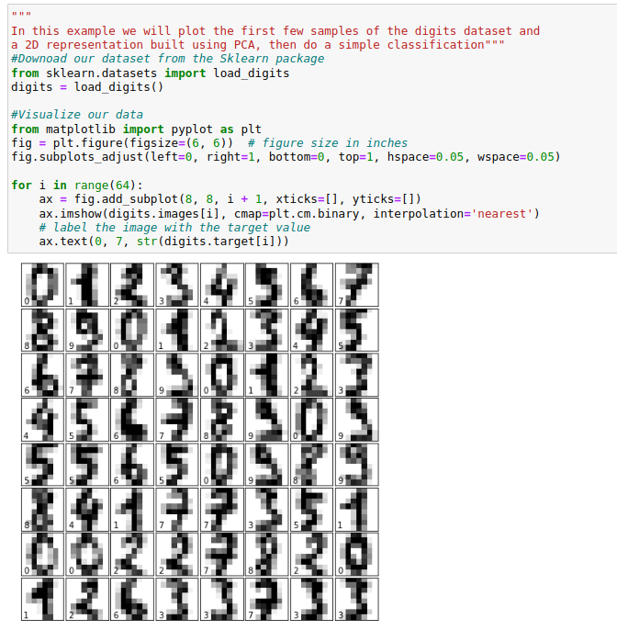
- In the scatter plot below, what do you notice about the distribution of different digits? Which digits overlap? What difficulties could this present to a classification model?
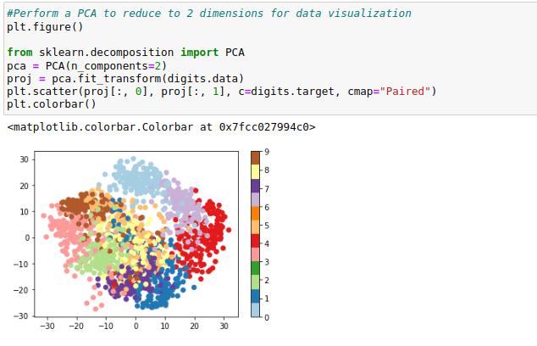
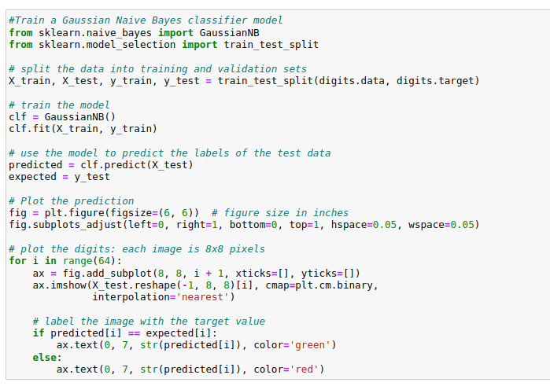
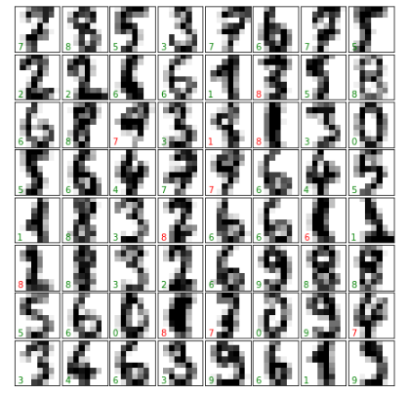

- How did our classifier perform? Why might it have made the errors that it did? Does this match with your intuition from the scatter plot above?
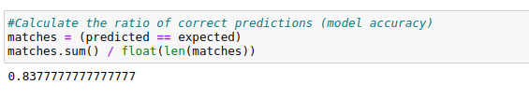

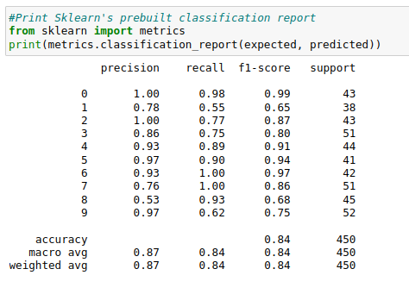

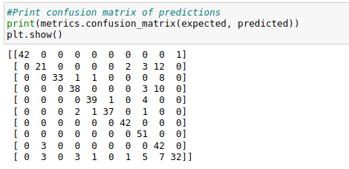

Online Program Readiness Short Evaluation
There is no “right” or “wrong” answer to these questions. Respond honestly.
- I am self-motivated and self-disciplined in the online learning environment, and I can allocate appropriate weekly time to obtain a master’s degree in artificial Intelligence.
- Yes
- No
- I’m not sure

- I am comfortable working and learning independently, and I can maintain a high motivation during the master’s program.
- Yes
- No
- I’m not sure

- I am good at setting goals and deadlines for myself to learn online technical graduate courses. I usually put a schedule and keep to it. I can turn in assignments and tasks on time without reminders.
- Yes
- No
- I’m not sure

- I like working in teams and virtual teamwork project settings, and I am responsive to teammates and very comfortable with online communications.
- Yes
- No
- I’m not sure

- I prefer learning about topics by having them explained directly rather than reading about them. I need to listen to face-to-face lectures on the concepts. I am also better at following oral instructions than written instructions.
- Yes
- No
- I’m not sure
Which option do you prefer (a or b)?
- I usually need a direct explanation from my professors and face-to-face interaction with my classmates to thoroughly grasp the content. I prefer face-to-face lectures (synchronous or hybrid learning) and meeting my classmates in-person to perform a team project or ask questions regarding assignments, programming, etc.
- I am an independent learner. I am comfortable learning on my own through reading the assigned textbooks, watching videos, participating in discussions, performing quizzes and assignments, and collaborating with my peers in hands-on projects using a Learning Management System (such as Blackboard). I take responsibility for my learning process and have no issue contacting my professors and classmates via e-mail or any other online tool if I have questions. When faced with difficulties or challenges in different graduate courses, I do not give up or quit. I use my problem-solving and research skills to find a solution.

- I am comfortable watching videos, studying materials, taking online quizzes, participating online discussions, and performing hands-on assignments every week?
- Yes
- No
- I’m not sure

Time Estimation & Management
Simply use the table below to estimate your time availability to allocate for the MS-AAI program weekly to perform readings, assignments, discussions, quizzes, and exams/projects.
Days | Hours
Tuesday (e.g., presentations/lectures/lab sessions/readings)
Wednesday (e.g., presentations/lectures/lab sessions/readings)
Thursday (e.g., readings/starting assignment/discussion posts)
Friday (e.g., assignment/discussion posts)
Saturday (e.g., assignment)
Sunday (e.g., assignment/quiz)
Monday (module deadline) (e.g., review and finalize deliveries)
Total

