Master of Science in Applied Data Science (MS-ADS) Self-assessment (Answer Key)

A Note to Prospective Students in Data Science:
Hello! Welcome, and congratulations on taking your first step towards this fast-paced and rewarding field. This self-assessment is designed to help you identify your level of preparedness for the Master of Science in Applied Data Science program. You will be able to get a good sense of your basic technical background and time management by completing this test. You should aim to answer all the questions in the assessment offline with limited effort in 1-4 hours.
The purpose of this self-assessment is only to highlight specific areas that may require extra preparation before beginning the program. Please do not be discouraged if you are unable to answer all the questions; this only indicates that you need to refresh and prepare those concepts and topics further. Additional information is embedded throughout the document, and we strongly encourage you to take advantage of the free resources on the Internet.

General Math
- $\log_{2}$ (8) = x What is x?

x=3 (2³ = 8)

- Write ${15}^{3/4}=8$ in logarithmic form.

$\log_{15}{8}=\frac{3}{4}$

More information on logarithms here.

- How many permutations can you make from the letters d,e,f?

6 permutations def, dfe, edf, efd, fde, fed

- How many permutations can you make from the letters a,b,c,d,e,f?

720 permutations (6*5*4*3*2*1 = 720)

- An ice cream parlor offers ten different toppings for their sundaes. How many different 3-topping sundae combinations (not allowing for double toppings) are there?

$\left(\begin{aligned}10 \\ 3\end{aligned}\right)=120$ sundae combinations

More information on permutations here.

- If A = {3,4,5,6,7} and B = {2,3,4,5,6,7,8}, what is $A∩B$ and $A∪B$?

$A∩B$= {3, 4, 5, 6, 7}
$A∪B$ = {2, 3, 4, 5, 6, 7, 8}

More information on sets here.

- What is the slope of the line that includes the points (-2, 2) and (-4, 8)?

$m=\frac{8-2}{-4-\left(-2\right)}=\frac{6}{-2}=-3$

More information on slopes here.

- True or False, $a^{0}=1$?

True

More information on the Zero Power Rule and exponents here.

- Simplify using the quotient rule $\frac{x^{4}}{x^{9}}=$?

$\frac{1}{x^{5}}$
More information on the Quotient Rule for Exponents here.

Calculus
- For x≠4, differentiate f(x)= $\frac{x^{2}}{4-x}$
f(x)= $\frac{8x-x²}{(4-x)²}$

More information on basic differentiation here.

- Evaluate $\lim_{x→8}\frac{2x^{2}-17x+8}{8-x}$

$\lim_{x→8}\frac{2x^{2}-17x+8}{8-x}$ $=\lim_{x→8}\frac{\left(2x-1\right)\left(x-8\right)}{-\left(x-8\right)}=\lim_{x→8}\frac{2x-1}{-1}=-15$

More information on limits here.

- Find the derivative of $f\left(y\right)\frac{4y^{3}-7y+8}{y}$

$f\left(y\right)=\frac{4y^{3}}{y}-\frac{7y}{y}+\frac{8}{y}=4y^{2}-7+8y^{-1}$ $f^{'}\left(y\right)=8y-8y^{-2}$

More information on derivative concepts here.

- Evaluate the following indefinite integral: $∫6x^{5}ⅆx-12x^{2}+8$
$x^{6}+c-12x^{2}+8$
More information on indefinite integrals here.

Probability
- If a fair coin was flipped 3 times and it landed on heads twice. What is the probability of this happening?

p(C)= p(H,T,H) + p(T, H, H) + p(H,H,T) = $3×\frac{1}{8}=37.5\%$

For more information please review here.

- 60% of swimmers do not wear goggles nor a swim cap. 20% wear goggles, and 30% wear swim caps. If one swimmer is chosen at random, what is the probability that he/she is wearing both goggles and a swim cap? It may be helpful to draw a Venn Diagram to visualize.

P( G or S) = 1 – 0.60 = 0.40
P (G or S) = P(G) + P(S) – P(G and S)
0.40 = 0.20 + 0.30 – P(G and S)
=P(G and S) = 0.10

More information on probability, intersection, and union of sets here.

- If one card is drawn from a standard 52 card deck, what is the probability it will be a red (hearts or diamonds) face card (king, queen, or jack?)
Face Card = 12/52 = 0.231 (red card) = 26/52 = 0.5 (red face card)=
Probability of Face Card x Probability of Red Card = 0.231 X 0.5 = 0.116

For more information please review here.

Linear Algebra
1. Consider matrix A = $\left[\begin{matrix}-4 & 0 \\ 0 & 1\end{matrix}\right]$ What are the eigenvalues of A?

-4, 1

For more information please review here.

2. Consider matrix B= $\left[\begin{matrix}2 & 3 & 4 \\ 3 & 6 & 7 \\ 4 & 5 & 9\end{matrix}\right]$ What is the transpose of B denoted by B^{T} ?

$\left[\begin{matrix}2 & 3 & 4 \\ 3 & 6 & 5 \\ 4 & 7 & 9\end{matrix}\right]$

For more information please review here.

3. Consider matrices C= $\left[\begin{matrix}2 & 1 & 3 \\ 0 & 8 & 0 \\ 1 & 5 & 3\end{matrix}\right]$ and D= $\left[\begin{matrix}1 & 0 & 7 \\ 3 & 4 & 9 \\ 0 & 8 & 0\end{matrix}\right]$ What is the sum of C + D?

$\left[\begin{matrix}3 & 1 & 10 \\ 3 & 12 & 9 \\ 1 & 13 & 3\end{matrix}\right]$

For more information please review here.

4. Perform the matrix multiplication: $\left[\begin{matrix}1 & 2 \\ 3 & 4\end{matrix}\right]$ x $\left[\begin{matrix}-2 & 3 \\ 4 & 5\end{matrix}\right]=$
$\left[\begin{matrix}6 & 13 \\ 10 & 29\end{matrix}\right]$
For more information please review here.

- If A = { 2, 4, 6, 8, 10, 12}. Which of the following are subsets of A?

- U = {3, 5}
- V = {2, 8, 10}
- W = {0}
- X = { 12, 10, 8, 6, 4, 2}
- Y = {6, 10, 2}
- Z = {4, 5, 6, 12}
For more information please review here.

Fundamentals of Statistics
- Match the statistical concept to the correct definition:
Concept | Definition
Mean | Total of all values divided by the number of values.
Mode | Value that appears most often in a dataset.
Range | Difference between the lowest and the highest value.
Median | Middle value in a list ordered from smallest to largest.
Variance | Measurement of the spread of values in a dataset, calculated by the average of the squared differences from the mean.
Standard Deviation | Measurement of dispersion, calculated using the square root of the variance.

For more information please review here.

- Find the median in the following list of numbers: 1, 3, 4, 5, 7, 8, 9, 12

(5 + 7) / 2 = 6
Median = 6

- A box of candy contains 6 solid chocolates, 4 chocolates with caramel filling, and 2 caramels. Draw a Venn Diagram to depict the different sets: Chocolate, Caramel + Chocolate, and Caramel. Then shade in A ∩ B on the Venn Diagram, where A is solid Chocolate, and B is Caramel.
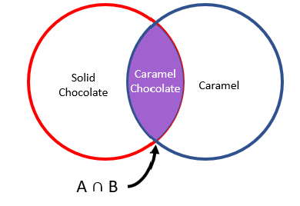
For more information please review here.

- If A and B are independent, and P(A) = 0.3 and P(B) = 0.5, please find P(A ∪ B).

P(A ∪ B) = 0.30 + 0.50 – 0.30 x 0.50 = 0.65

For more information please review here.

- Please match the type of variable with the correct definition.
Variable Name |  | Definition
Categorical |  | A variable that can be put into categories, also known as a nominal variable.
Ordinal |  | Variables that can be ranked.
Discrete |  | Numeric variables that have a finite number of values.
Continuous |  | Numeric variables that take any value in an infinite range.
Binary |  | Nominal variables that only have two categories or levels. Also referred to as dichotomous.
Ratio |  | Interval variable that has a meaningful zero.
Interval |  | Variables with a numerical value and can be measured along a continuum.
Nominal |  | Variables that have at least two categories without intrinsic order.
Qualitative |  | Variable that is non-numerical with data that fits into categories.
Quantitative |  | Numerical variables that represent a measurement of quantity.

For more information please review here.

Cafeteria Menu
Entrée | Type | Total Calories | Protein (g) | Sugar (g)
Turkey Sandwich | Cold | 400 | 25 | 5
Spaghetti and Meatballs | Hot | 750 | 20 | 15
Cesar Salad | Cold | 350 | 5 | 7
Grilled Cheese | Hot | 625 | 15 | 10

- Please refer to the table above. What are the individuals in this dataset?

- The Cafeteria’s customers
- Entrée
- Type
- Menu

- Please refer to the table above. In the Cafeteria Menu portion of the table, how many variables are there, and of those variables, how many are categorical?

- 5 variables, 2 categorical
- 5 variables, 1 categorical
- 4 variables, 1 categorical
- 4 variables, 0 categorical
For more information please review here.
- Give an example of univariate and bivariate observations? Are multivariate and bivariate the same?

Univariate example: heartbeat measured by beats per minute (1 variable)
Bivariate example: systolic and diastolic blood pressure measurement (2 variables)
Multivariate example: 2 or more observations. Multivariate can be bivariate.

For more information please review here.

Excel
You have been given access to an Excel file containing grant funding applications. The table has 5 columns:
- Application_id: grant application ID
- Budget_start: date when the grant payments start
- project_title: title appearing on the grant application
- Support_year: number of years the grant will remain active
- Total_cost: the total dollar amount awarded by the grant
*Please copy and paste the following dataset into Excel or download data as a Microsoft Excel file from the website.
application_id | budget_start | project_title | support_year | total_cost
9223315 | 2/5/2019 | Dietary factors, biomarkers, metabolic pathways related to non-alcoholic fatty liver disease | 1 | 249000
9334591 | 12/1/2018 | P2 Study of Clofazimine for Pulmonary M. avium Disease IND 125,266 (1/5/2015) | 2 | 495835
9485561 | 2/1/2019 | Multidisciplinary Training in Digestive Diseases | 44 | 372638
9489206 | 12/1/2018 | Early-Stage Chronic Kidney Disease in HIV-infected Individuals | 9 | 625114
9491549 | 3/1/2019 | Mechanisms of varicella virus-induced multisystem disease using a primate model | 11
9554875 | 8/1/2019 | Probiotics for Prevention of Acute Graft-vs-Host Disease in Children with Cancer | 4 | 744609
9561532 | 10/1/2018 | The neuropathology of mild traumatic brain injury in Alzheimer disease | 5
9597224 | 12/1/2018 | Hormones in allergic disease | 3 | $ 392,487.00
9600088 | 12/1/2018 | Molecular Genetic Insight into Neurodegenerative Disease from Drosophila | 3 | 703113
9601647 | 12/1/2018 | Mechanisms of IL-33 secretion in allergic diseases | 3 | 510759
9605113 | 12/1/2018 | Non-invasive Intracranial Pressure Sensing with Near Infrared Light for Monitoring the Healthy and Diseased Brain | 2 | 186255
9605217 | 10/1/2018 | Regulation of extrasynaptic GABA-A receptors in health and disease | 4
9605233 | 10/1/2018 | Dietary Fat and Alcoholic Liver Disease | 3
9606377 | 12/1/2018 | The role of IL10 in early vascularity, endothelial dysfunction, and programming of adult cardiovascular disease | 2 | 178524
9608053 | 12/1/2018 | Tip60, Ischemic Heart Disease and Regeneration | 3 | 501446
9608768 | 1/1/2019 | Translational Program in CFTR-Related Airway Diseases | 3 | 917966
9608791 | 12/1/2018 | VITAMIN D DEFICIENCY, INSULIN RESISTANCE AND CARDIOVASCULAR DISEASE | 8 | 381900
9608792 | 2/1/2019 | IU training Program in Molecular Physiology and Clinical Mechanisms of Lung Disease | 10 | 245539
9609465 | 12/1/2018 | Academic Training Program in Pediatric Pulmonary Disease | 30 | 221162
9610656 | 1/1/2019 | Molecular Mechanisms of Pigmentation in Health and Disease | 2 | 342000
9610698 | 12/1/2018 | Non-Contrast-Enhanced Velocity-Selective MR Angiography at 3T for Cerebrovascular Diseases | 2 | 404000
9085817 | 9/1/2016 | STorytelling to Improve DiseasE outcomes in GoUT: The STRIDE-GO Study | 1
9565043 | 1/1/2019 | New approaches to combat CNS inflammation in Veterans: Targeting a metabolic enzyme in demyelinating disease | 1
9588799 | 2/1/2019 | Vascular-associated neuroinflammation in Alzheimer’s disease: differential effects on disease progression modulated by underlying amyloid burden | 2 | 61610
9591280 | 1/1/2019 | Krüppel-Like Factor 15 is a novel mediator of glucocorticoid-responsive glomerular disease | 2
9598331 | 12/1/2018 | Macrophage differentiation and disease outcome in influenza infection | 3 | 542926
9613207 | 1/1/2019 | Multivalent Toxoid Vaccine for Prevention of S. aureus Invasive Diseases | 5 | 761776
9613228 | 1/1/2019 | Identifying a nodal point for G alpha q signaling in eye disease | 4 | 330612
9613769 | 1/1/2019 | Causal Inference in Infectious Disease Prevention Studies | 9 | 378114
9613856 | 1/1/2019 | Symptom burden in End-Stage Liver Disease patient-caregiver dyads | 4 | 385000
9616316 | 1/1/2019 | Fetal Brain Development in Congenital Heart Disease | 3 | 189954
9617236 | 12/1/2018 | Integrative genomic, epigenetic and functional studies in diabetic kidney disease | 4 | 725688
9617699 | 1/1/2019 | Disease-Induced Modification in Nanoparticle-Corona Identity and Toxicity | 5 | 249000
9617787 | 12/1/2018 | microRNAs in vascular diseases | 8 | 425953

- In the Excel file, add filters to the table and sort support_year from smallest to largest.

- Click on data.
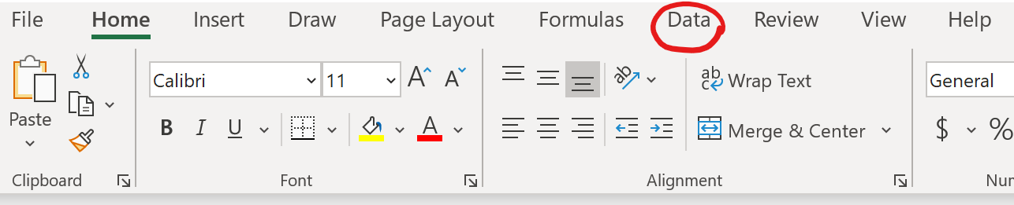

- Click on filter.
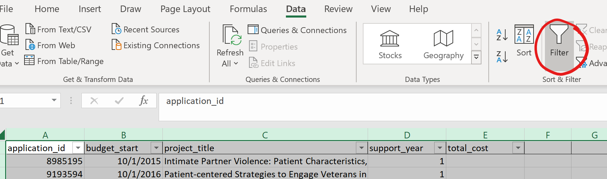
- Click on the dropdown menu for support_year, then sort by smallest to largest.
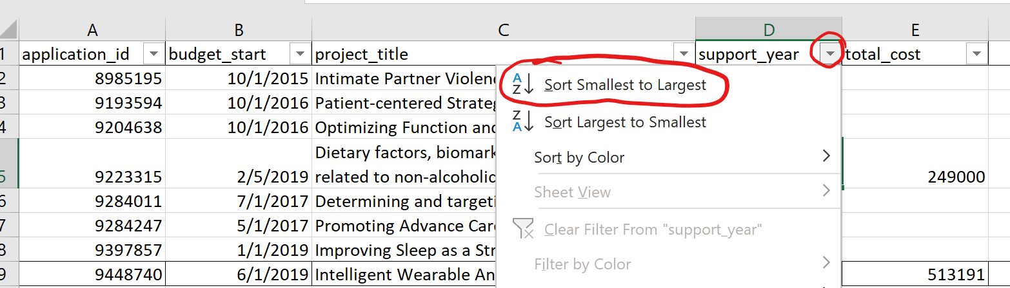

- Format the budget_start column as YYYY-MM-DD.

- Select the budget_start column
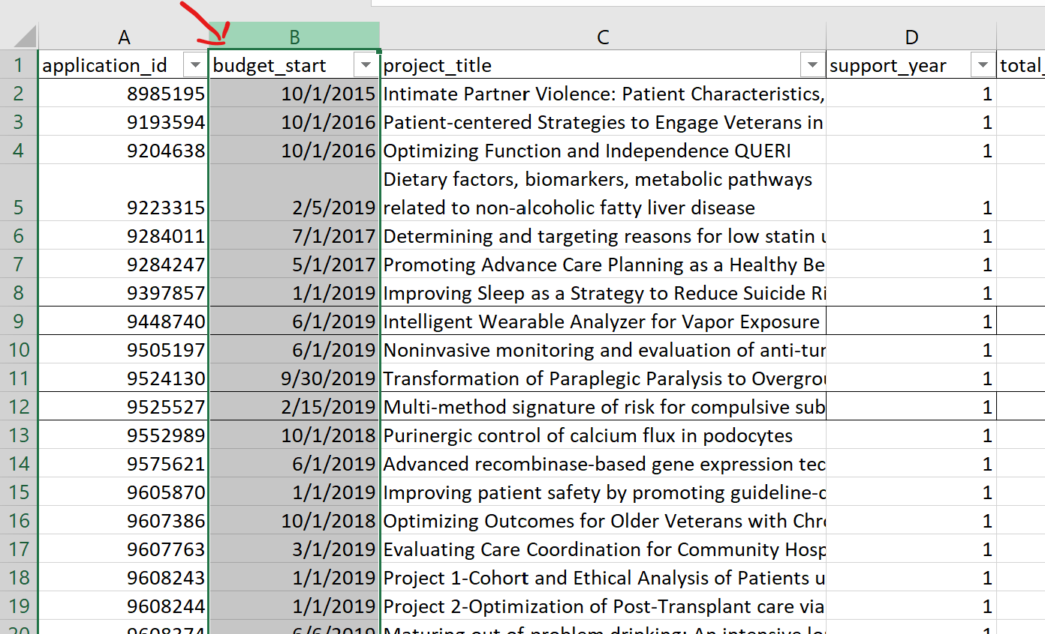
- Right-click and select format cells.
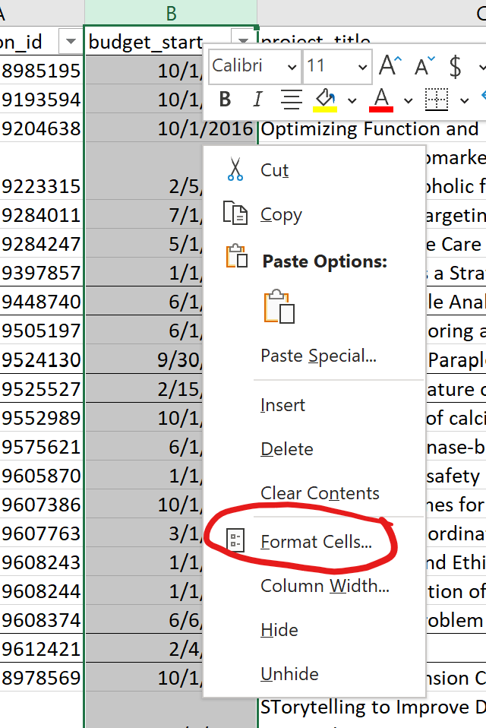
- Select “date.”
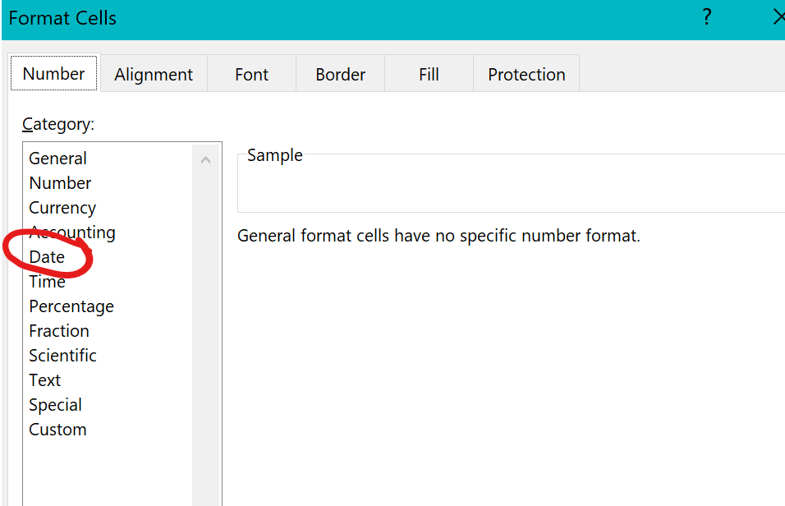
- Select YYYY-MM-DD.
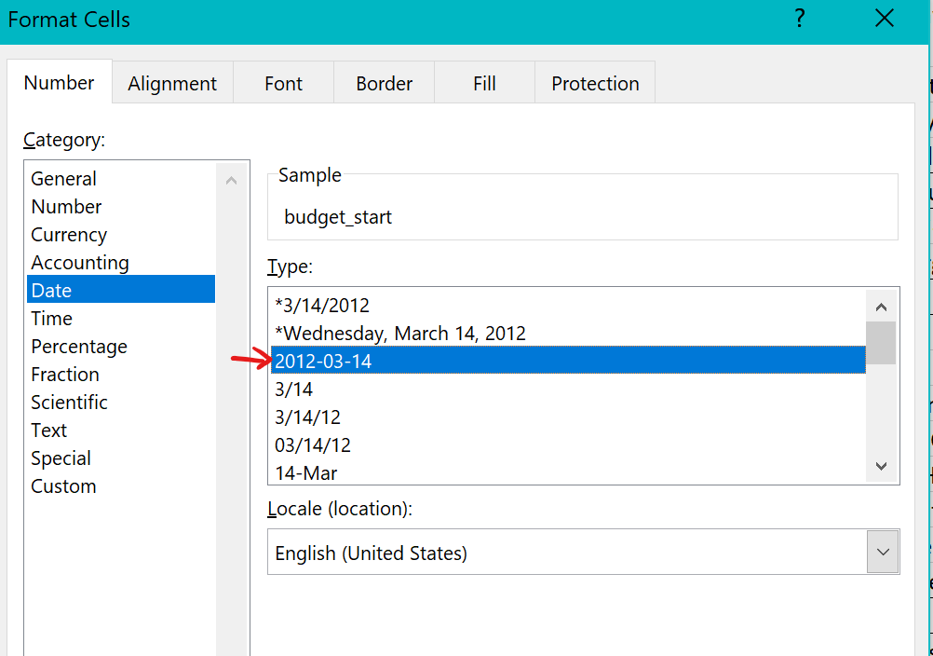

- Freeze the top row, so the column names remain visible while you scroll down the rows.

- Click on View.
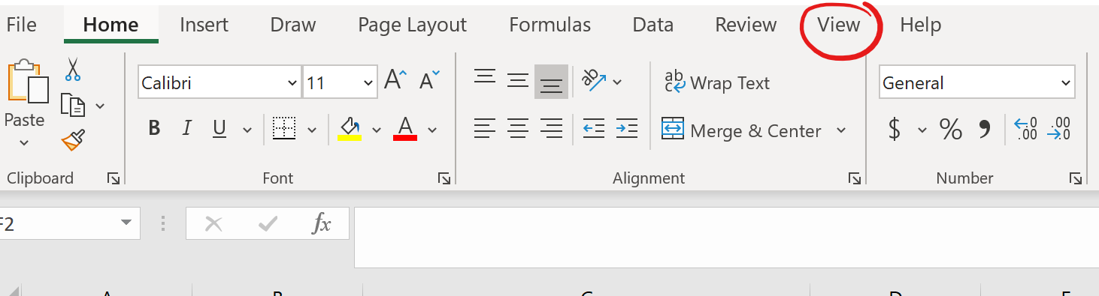
- Click on “Freeze Panes” and select “Freeze Top Row.”
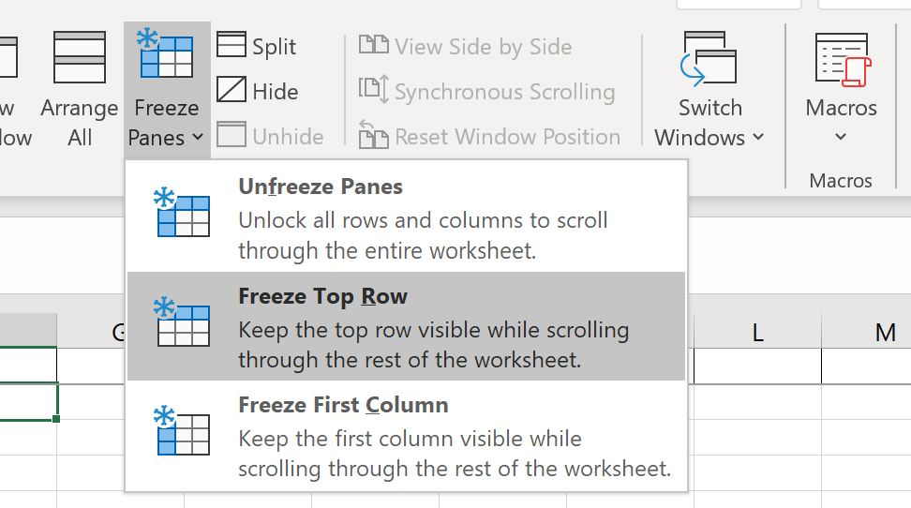
- You are asked to create a new column next to “total_cost” called “priority,” labeling all projects with a “total_cost” over $20,000 as “high” and anything under $20,000 as “low.” Write an IF statement to quickly accomplish this task.

- Click on the cell under column “F” and type in the column title. 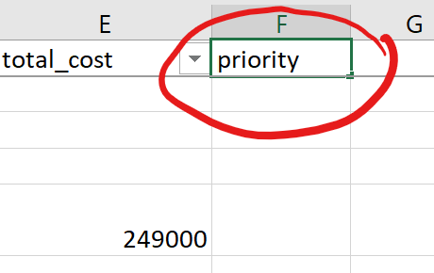

- Write the IF statement in cell “F2.”
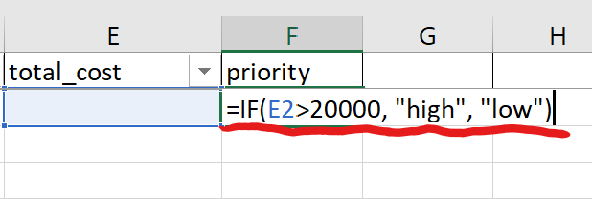
- Then double click on the square in the bottom righthand corner of the cell.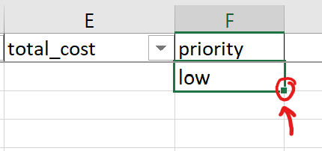

- The values will be filled in for the entirety of the dataset.
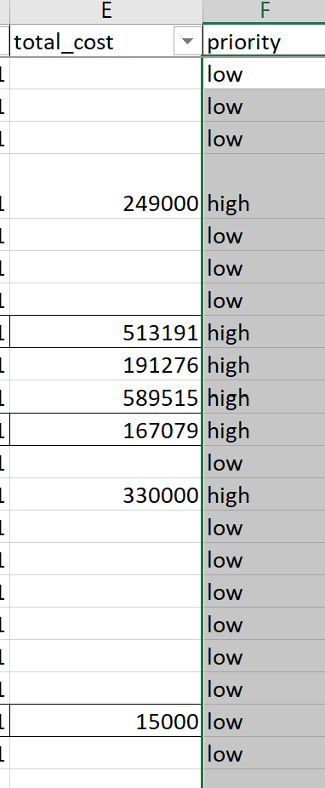
- Alternatively, you can copy the formula in “E2” using “Control” and “C” then use “Control,” “Shift,” “End,” and hit “Enter,” and the formula will be copied down the dataset.

- Excel provides quick graphing of data by simply clicking “Insert” and selecting the chart you wish to create. Can you name these different graphs?
- Pie Chart
- Bar Graph
- Line Graph
- Scatter Plot

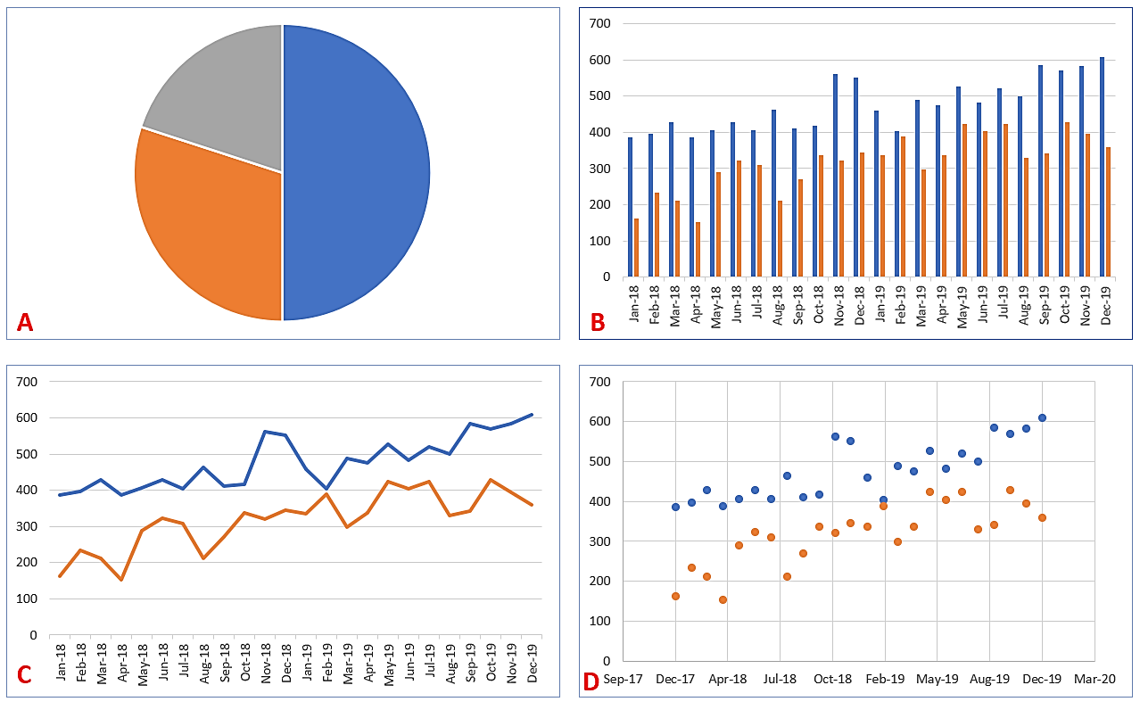

APA Writing Style
You will use APA 7 style, a writing format for academic documents, in your reports and presentations in the MS-ADS program.
1. Which of the following is cited correctly in APA in-text citations of an article with three or more authors?
- Tarshizi, Cooke, Smith, Kim (2020)
- Tarshizi, et. al. 2020
- (Tarshizi et al., 2020, p. 155)
- Tarshizi…& Kim (2020, pp. 155)

2. In APA 7 style, a separate title page is required for a document or report.
- True
- False

3. Running heads are optional on all APA 7th edition papers.
a) True
b) False

Purdue University has an excellent APA 7th Edition quick reference guide.

Programming
- What is the value of x after the following code snippet is executed?
n = 5
m = 8
l = 4
x = 0
if (m > l) and (n > m) then
x = 5
else
if (m >= 10) then
x = 6
else
x = 7
end if
end if

- x = 0
- x = 5
- x = 6
- x = 7
For more information please review here.

- Given the array below, what is the value of “sum” at the end of the execution of the following piece of code: (assume that array index starts at 0 and “loop” increments variable “i”)

5 | 2 | 7 | 1 | 2 | 6

array =

sum = 0
loop i = 0 to 6
if (i == 0 or i == 3) then
sum = sum + array[i]
end if
end loop

- sum = 0
- sum = 5
- sum = 6
- sum = 11

For more information please review here.

- The purpose of this part is to review sample Python code (as examples) and consider if you would enjoy learning and writing similar computer code (programming) in Data Science. In addition, do you know what the name of the plot created in example #3 is?
- Distribution Plots
- Scatter Plot Matrix
- Heatmap
- Sankey Plots

Example #1:
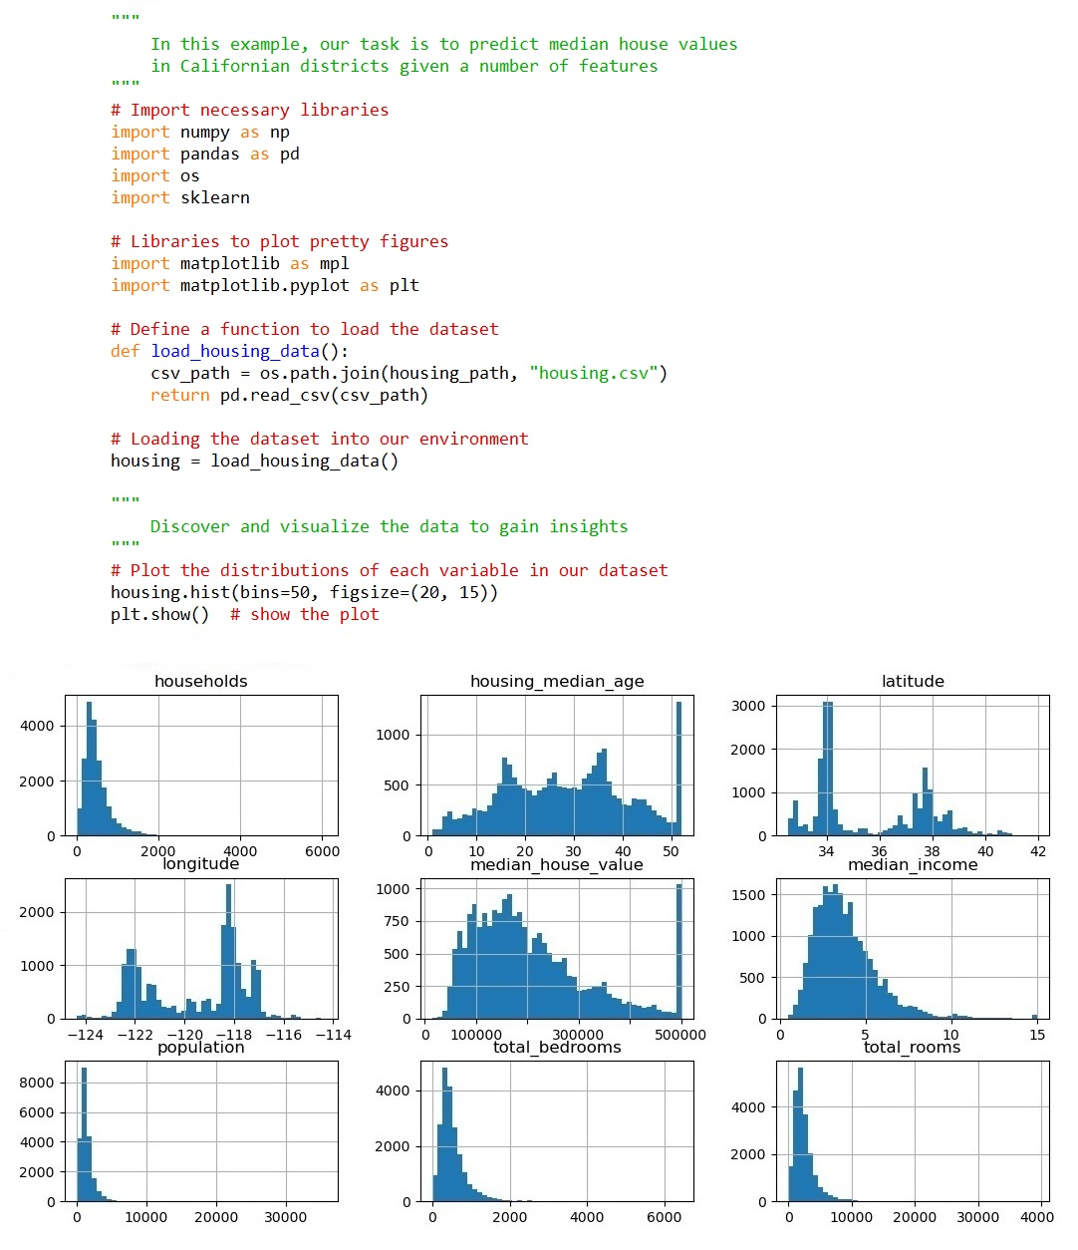

Example #2:
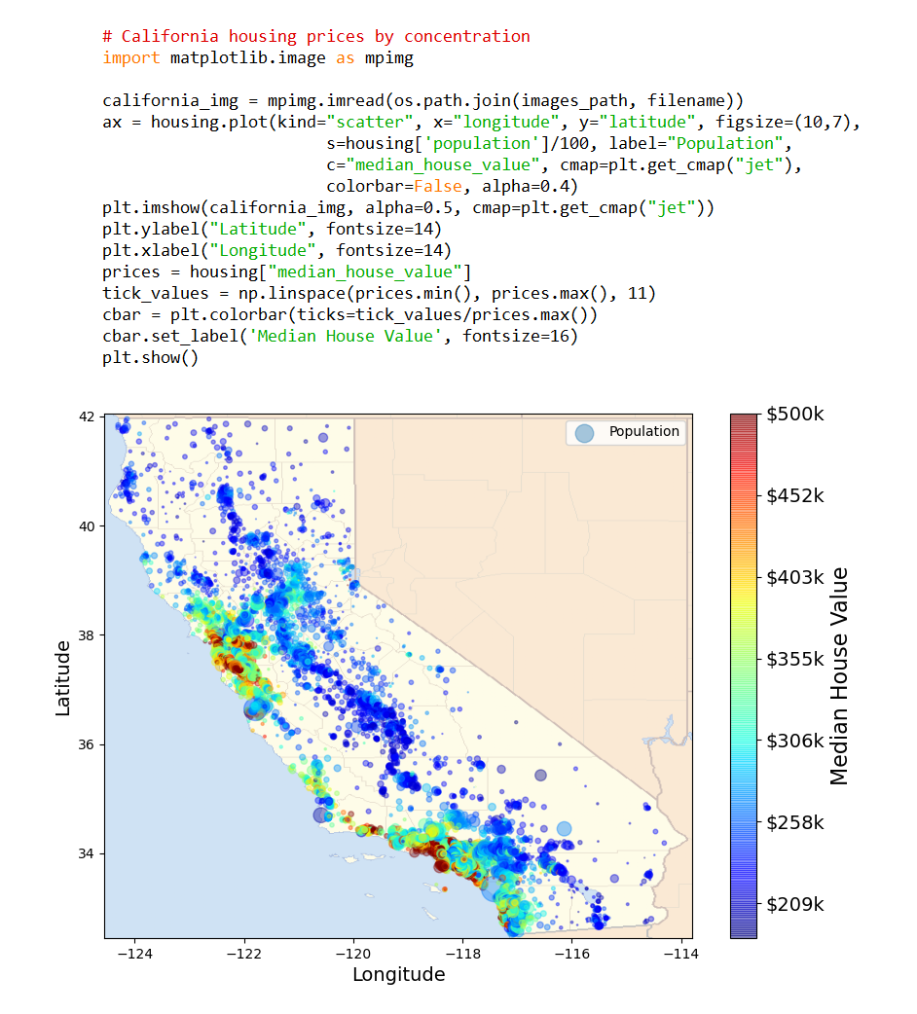

Example #3:
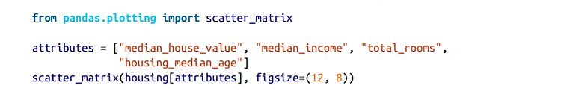
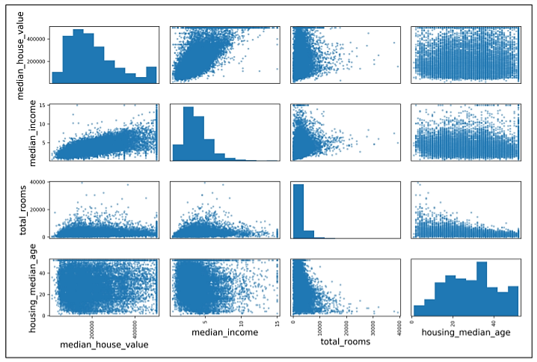

Online Program Readiness Short Evaluation
There is no “right” or “wrong” answer to these questions. Respond honestly.
- I am self-motivated and self-disciplined in the online learning environment, and I can allocate appropriate weekly time to obtain a master’s degree in data science.
- Yes
- No
- I’m not sure

- I am comfortable working and learning independently, and I can maintain a high motivation during the master’s program.
- Yes
- No
- I’m not sure

- I am good at setting goals and deadlines for myself to learn online technical graduate courses. I usually put a schedule and keep to it. I can turn in assignments and tasks on time without reminders.
- Yes
- No
- I’m not sure

- I like working in teams and virtual teamwork project settings, and I am responsive to teammates and very comfortable with online communications.
- Yes
- No
- I’m not sure

- I prefer learning about topics by having them explained rather than reading about them. I need to listen to face-to-face lectures on the concepts. I am also better at following oral instructions than written instructions.
- Yes
- No
- I’m not sure
Which option do you prefer (a or b)?
- I usually need a direct explanation from my professors and face-to-face interaction with my classmates to thoroughly grasp the content. I prefer face-to-face lectures (synchronous or hybrid learning) and meeting my classmates in-person to perform a team project or ask questions regarding assignments, programming, etc.
- I am an independent learner. I am comfortable learning on my own through reading the assigned textbooks, watching videos, participating in discussions, performing quizzes and assignments, and collaborating with my peers in hands-on projects using a Learning Management System (such as Blackboard). I take responsibility for my learning process and have no issue contacting my professors and classmates via e-mail or any other online tool if I have questions. When faced with difficulties or challenges in different graduate courses, I do not give up or quit. I use my problem-solving and research skills to find a solution.

Time Estimation & Management
Simply use the table to estimate your time availability to allocate for the MS-ADS program weekly to perform readings, assignments, discussions, quizzes, and exams/projects.
We highly recommend that our students allocate and spend about 18-22 hours per week on readings, assignments, projects, quizzes, etc., in this program.

A Few Notes on Time Management and Reducing Stress:
- Visually prioritize your time with a monthly calendar that shows all major due dates. Create a daily to-do list with study-time goals and assignments you plan to complete.
- Study efficiently through highlighting and taking notes to easily see the main points. Consider even using your time to study while you are waiting for an appointment, etc.
- Learn the time of day you are most the most productive, whether that is early morning or late at night. Use this time to your advantage to complete your work/reading.
- Many students have anxiety about learning the programming languages required for this field. As with learning any new language, at first, it might be difficult, but with practice and repetition, you will get the hang of it. MS-ADS understands students with different technical backgrounds are entering into the program and have designed the introductory programming courses to accommodate true beginners.
- Give yourself some grace. Even if you did not accomplish all your goals for the day, know your limits, and give yourself a pass. Make sure you schedule a time for hobbies and socializing to provide yourself with a very important and much needed mental outlet.

A Few Hints on Being a Good Team Player in the MS-ADS Group Projects:
- Actively listen and participate in e-meetings.
- Establish effective communication channels using Slack, Zoom, e-mail, and phone.
- Respect teammates’ time and roles. Meet your deadlines.
- Be positive and a problem-solver in challenging cases and data-driven projects.
- Flex to others’ work styles. Bring high-quality work to the team.
- Focus on collaboration, not just cooperation.
- Celebrate your teammates’ successes.

Free Preparation Resources for Starting a Data Science Graduate Program:
- Khan Academy: Calculus
- Khan Academy: Statistics
- Math is Fun: Statistics
- Khan Academy: Linear Algebra
- Calculus eTextbook by Gilbert Strang
- Welcome to Excel Easy
- Excel Tutorial
- LearnPython.org: free interactive Python tutorial
- DataCamp.com: free interactive Introduction to Python
- DataCamp.com: free interactive R Introductory Course
- Introduction to R by Udemy
- learnsqlonline.org: free interactive SQL tutorial
- 15 MOOCs (Massive Open Online Courses) for Data Science
- MS-ADS GitHub Materials
- MS-ADS Blog
- Data Science Blog: Toward Data Science
- Data Science News, Datasets, Tutorials, and Blog: KDnuggets

