Master of Science in Applied Artificial Intelligence (MS-AAI) Self-assessment (Answer Key)

A Note to Prospective Students in Artificial Intelligence:
Hello! Welcome, and congratulations on taking your first step towards this fast-paced and rewarding field. This self-assessment is designed to help you identify your level of preparedness for the Master of Science in Applied Artificial Intelligence Program at USD. You will be able to get a good sense of your basic technical background and time management by completing this test. You should aim to answer all the questions in the assessment offline with limited effort in 1-4 hours.
The purpose of this self-assessment is only to highlight specific areas that may require extra preparation before beginning the program. Please do not be discouraged if you are unable to answer all the questions; this only indicates that you need to refresh and prepare those concepts and topics further. Additional information is embedded throughout the document, and we strongly encourage you to take advantage of the free resources on the Internet.

General Math
- $\log_{2}$ (8) = x What is x?

x=3 (2³ = 8)

- Write ${15}^{3/4}=8$ in logarithmic form.

$\log_{15}8=\frac{3}{4}$

More information on logarithms here.

- How many permutations can you make from the letters a,b,c,d,e,f?

720 permutations (6*5*4*3*2*1 = 720)

- An ice cream parlor offers ten different toppings for their sundaes. How many different 3-topping sundae combinations (not allowing for double toppings) are there?

$\left(\begin{aligned}10 \\ 3\end{aligned}\right)=120$ sundae combinations

More information on permutations here.

- If A = {3,4,5,6,7} and B = {2,3,4,5,6,7,8}, what is $A∩B$ and $A∪B$?

$A∩B$= {3, 4, 5, 6, 7}
$A∪B$ = {2, 3, 4, 5, 6, 7, 8}

More information on sets here.

- What is the slope of the line that includes the points (-2, 2) and (-4, 8)?

$m=\frac{8-2}{-4-\left(-2\right)}=\frac{6}{-2}=-3$

More information on slopes here.

- True or False, $a^{0}=1$?

True

More information on the Zero Power Rule and exponents here.

- Simplify using the quotient rule $\frac{x^{4}}{x^{9}}=$?

$\frac{1}{x^{5}}$
More information on the Quotient Rule for Exponents here.

Calculus
- For x≠4, differentiate f(x)= $\frac{x^{2}}{4-x}$
f(x)= $\frac{8x-x²}{\left(4-x\right)²}$

More information on basic differentiation here.

- Evaluate $\frac{\lim_{x→8}{2x^{2}-17x+8}}{8-x}$

$\frac{\lim_{x→8}{2x^{2}-17x+8}}{8-x}$ $\frac{\lim_{x→8}\left(2x-1\right)\left(x-8\right)}{-\left(x-8\right)}=\frac{\lim_{x→8}{2x-1}}{-1}=-15$

More information on limits here.

- Find the derivative of $f\left(y\right)={\left(2y^{2}+y\right)}^{3}$

$f\left(y\right)=3{\left(2y^{2}+y\right)}^{2}\left(2y^{2}+y\right)'=3\left(2y^{2}+y\right)\left(4y+1\right)$

More information on derivative concepts here.

- Evaluate the following indefinite integral with respect to $x$: $∫6x^{5}ⅆx-12x^{2}+8$
$x^{6}+c-12x^{2}+8$
More information on indefinite integrals here.
5. For $f\left(x_{1},x_{2},x_{3},x_{4}\right)=3cos\left(x_{1}x_{4}\right)sin\frac{\left(x_{2}^{5}\right)}{e_{2}^{x}+{\left(1+x_{2}^{2}\right)}/{\left(x_{1}x_{2}x_{4}\right)}}+5x_{1}x_{3}x_{4}$ calculate $\frac{∂f}{∂x_{3}}\left(a,b,c,d\right)$
Since the first term does not involve $x_{3}$, it can be treated as a constant, for which the derivative is zero. Thus, the derivative comes solely from the second term:
$$\frac{∂f}{∂x_{3}}\left(a,b,c,d\right)=5\left(x_{1}x_{4}\right)=5ad$$

Probability
- If a fair coin was flipped 3 times and it landed on heads twice. What is the probability of this happening?

p(C)= p(H,T,H) + p(T, H, H) + p(H,H,T) = $3×\frac{1}{8}=37.5\text{\%}$

For more information, please review here.

- 60% of swimmers do not wear goggles nor a swim cap. 20% wear goggles, and 30% wear swim caps. If one swimmer is chosen at random, what is the probability that he/she is wearing both goggles and a swim cap? It may be helpful to draw a Venn Diagram to visualize.

P( G or S) = 1 – 0.60 = 0.40
P (G or S) = P(G) + P(S) – P(G and S)
0.40 = 0.20 + 0.30 – P(G and S)
=P(G and S) = 0.10

More information on probability, intersection, and union of sets here.

- If one card is drawn from a standard 52 card deck, what is the probability it will be a red (hearts or diamonds) face card (king, queen, or jack?)
Face Card = 12/52 = 0.231 (red card) = 26/52 = 0.5 (red face card)=
Probability of Face Card x Probability of Red Card = 0.231 X 0.5 = 0.116

For more information, please review here.

Linear Algebra
1. Consider matrix A = $\left[\begin{matrix}-6 & 3 \\ 4 & 5\end{matrix}\right]$ What are the eigenvalues of A?

-7,6

For more information, please review here.

2. For matrix A, above, find an eigenvector for either of the eigenvalues that you identified.

$$λ=6$$
$$Av=λv$$
$$\left[\begin{matrix}-6 & 3 \\ 4 & 5\end{matrix}\right]\left[\begin{matrix}x \\ y\end{matrix}\right]=6\left[\begin{matrix}x \\ y\end{matrix}\right]$$

$$-6x+3y=6x$$
$$4x+5y=6y$$

$$y=4x$$

Any multiple of $\left[\begin{matrix}1 \\ 4\end{matrix}\right]$ will be an eigenvector for the eigenvalue $λ=6$
3. Consider matrix B = $\left[\begin{matrix}2 & 3 & 4 \\ 3 & 6 & 7 \\ 4 & 5 & 9\end{matrix}\right]$ What is the transpose of B denoted by B^{T} ?

$\left[\begin{matrix}2 & 3 & 4 \\ 3 & 6 & 5 \\ 4 & 7 & 9\end{matrix}\right]$

For more information, please review here.

4. Consider matrices C = $\left[\begin{matrix}2 & 1 & 3 \\ 0 & 8 & 0 \\ 1 & 5 & 3\end{matrix}\right]$ and D = $\left[\begin{matrix}1 & 0 & 7 \\ 3 & 4 & 9 \\ 0 & 8 & 0\end{matrix}\right]$ What is the sum of C + D?

$\left[\begin{matrix}3 & 1 & 10 \\ 3 & 12 & 9 \\ 1 & 13 & 3\end{matrix}\right]$

For more information, please review here.

5. Perform the matrix multiplication: $\left[\begin{matrix}1 & 2 \\ 3 & 4\end{matrix}\right]$ x $\left[\begin{matrix}-2 & 3 \\ 4 & 5\end{matrix}\right]=$
$\left[\begin{matrix}6 & 13 \\ 10 & 29\end{matrix}\right]$
For more information, please review here.

6. True or False, for matrices A and B, $\left(A^{T}\right)x\left(B^{T}\right)={\left(BA\right)}^{T}$

True

For more information, please review here

7. If A = {2, 4, 6, 8, 10, 12}. Which of the following are subsets of A?

- U = {3, 5}
- V = {2, 8, 10}
- W = {0}
- X = { 12, 10, 8, 6, 4, 2}
- Y = {6, 10, 2}
- Z = {4, 5, 6, 12}
For more information, please review here.

Fundamentals of Statistics
- Match the statistical concept to the correct definition:
Concept | Definition
Mean | Total of all values divided by the number of values.
Mode | Value that appears most often in a dataset.
Range | Difference between the lowest and the highest value.
Median | Middle value in a list ordered from smallest to largest.
Variance | Measurement of the spread of values in a dataset, calculated by the average of the squared differences from the mean.
Standard Deviation | Measurement of dispersion, calculated using the square root of the variance.

For more information, please review here.

- Find the median in the following list of numbers: 1, 3, 4, 5, 7, 8, 9, 12

(5 + 7) / 2 = 6
Median = 6

- A box of candy contains 6 solid chocolates, 4 chocolates with caramel filling, and 2 caramels. Draw a Venn Diagram to depict the different sets: Chocolate, Caramel + Chocolate, and Caramel. Then shade in A ∩ B on the Venn Diagram, where A is solid Chocolate, and B is Caramel.
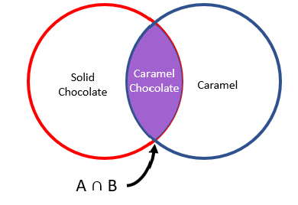
For more information, please review here.

- If A and B are independent, and P(A) = 0.3 and P(B) = 0.5, please find P(A ∪ B).

P(A ∪ B) = 0.30 + 0.50 – 0.30 x 0.50 = 0.65

For more information, please review here.

- Please match the type of variable with the correct definition.
Variable Name |  | Definition
Categorical |  | A variable that can be put into categories, also known as a nominal variable.
Ordinal |  | Variables that can be ranked.
Discrete |  | Numeric variables that have a finite number of values.
Continuous |  | Numeric variables that take any value in an infinite range.
Binary |  | Nominal variables that only have two categories or levels. Also referred to as dichotomous.
Ratio |  | Interval variable that has a meaningful zero.
Interval |  | Variables with a numerical value and can be measured along a continuum.
Nominal |  | Variables that have at least two categories without intrinsic order.
Qualitative |  | Variable that is non-numerical with data that fits into categories.
Quantitative |  | Numerical variables that represent a measurement of quantity.

For more information, please review here.

Cafeteria Menu
Entrée | Type | Total Calories | Protein (g) | Sugar (g)
Turkey Sandwich | Cold | 400 | 25 | 5
Spaghetti and Meatballs | Hot | 750 | 20 | 15
Cesar Salad | Cold | 350 | 5 | 7
Grilled Cheese | Hot | 625 | 15 | 10

- Please refer to the table above. What are the independent variables in this dataset?

- The Cafeteria’s customers
- Entrée
- Type
- Menu

- Please refer to the table above. In the Cafeteria Menu portion of the table, how many dependent variables are there, and of those, how many are categorical?

- 5 variables, 2 categorical
- 5 variables, 1 categorical
- 4 variables, 1 categorical
- 4 variables, 0 categorical
For more information, please review here.
- Give an example of univariate and bivariate observations? Are multivariate and bivariate the same?

Univariate example: heartbeat measured by beats per minute (1 variable)
Bivariate example: systolic and diastolic blood pressure measurement (2 variables)
Multivariate example: 2 or more observations. Multivariate can be bivariate.

For more information, please review here.

APA Writing Style
You will use APA 7 style, a writing format for academic documents, in your reports and presentations in the MS-AAI program.
1. Which of the following is cited correctly in APA in-text citations of an article with three or more authors?
- Tarshizi, Cooke, Smith, Kim (2020)
- Tarshizi, et. al. 2020
- (Tarshizi et al., 2020, p. 155)
- Tarshizi…& Kim (2020, pp. 155)

2. In APA 7 style, a separate title page is required for a document or report.
- True
- False

3. Running heads are optional on all APA 7th edition papers.
a) True
b) False

Purdue University has an excellent APA 7th Edition quick reference guide.

Programming
- What is the value of x after the following code snippet is executed?
n = 5
m = 8
l = 4
x = 0
if (m > l) and (n > m) then
x = 5
else
if (m >= 10) then
x = 6
else
x = 7
end if
end if

- x = 0
- x = 5
- x = 6
- x = 7
For more information, please review here.

- Given the array below, what is the value of “sum” at the end of the execution of the following piece of code? (assume that array index starts at 0 and “loop” increments variable “i”)

5 | 2 | 7 | 1 | 2 | 6

array =

sum = 0
loop i = 0 to 6
if (i == 0 or i == 3) then
sum = sum + array[i]
end if
end loop

- sum = 0
- sum = 5
- sum = 6
- sum = 11

For more information, please review here.

3. The purpose of this section is to only review sample Python code and problem-solving to consider if you would enjoy writing code (programming) and answering these sorts of questions to solve problems using AI. Example code taken from the Scikit-learn tutorials.

- In the scatter plot below, we visualize the distribution of images of digits (0-9) when reduced to two dimensions using PCA. What do you notice about the distribution of different digits? Which digits overlap? What difficulties could this present to a classification model?

The eights have significant overlap with several other digits. If the data for different digits are all very similar, it will be difficult for the model to learn how to tell them apart.
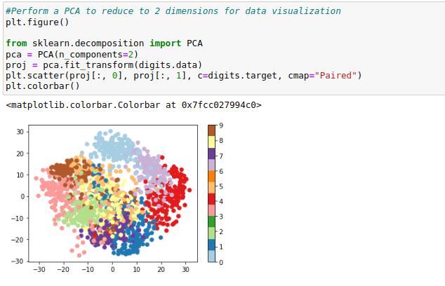
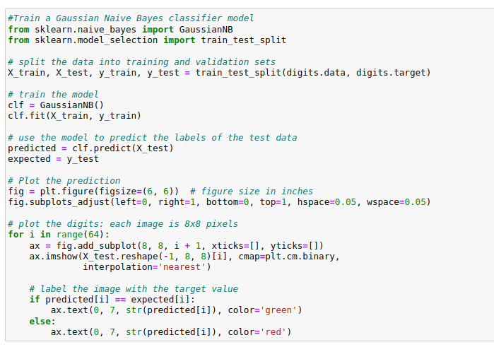
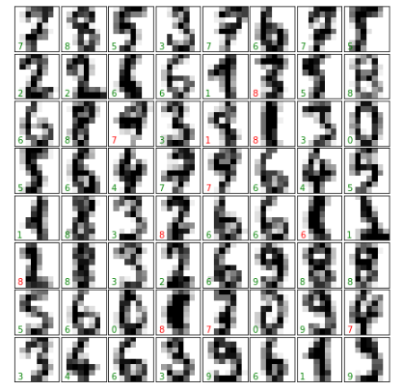
- How did our classifier perform? Why might it have made the errors that it did? Does this match with your intuition from the scatter plot above?
Many of the errors in the sample above are digits that are misclassified as eights, as would be expected from the overlap seen in the scatter plot. However, we also see several digits misclassified as sevens—going back to the scatter plot shows that sevens do overlap some other digits as well. In all the examples of misclassifications here, the digits that are misclassified would be difficult for a human to distinguish as well.
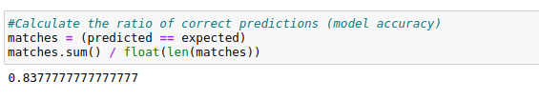

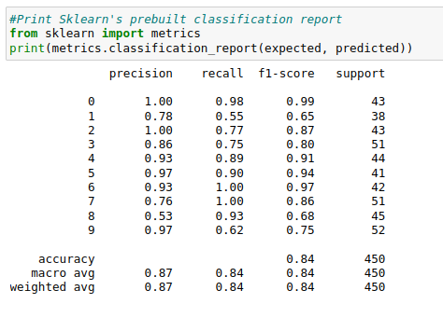

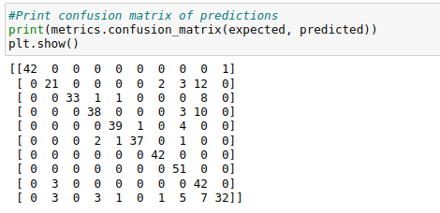

Online Program Readiness Short Evaluation
There is no “right” or “wrong” answer to these questions. Respond honestly.
- I am self-motivated and self-disciplined in the online learning environment, and I can allocate appropriate weekly time to obtain a master’s degree in artificial Intelligence.
- Yes
- No
- I’m not sure

- I am comfortable working and learning independently, and I can maintain a high motivation during the master’s program.
- Yes
- No
- I’m not sure

- I am good at setting goals and deadlines for myself to learn online technical graduate courses. I usually put a schedule and keep to it. I can turn in assignments and tasks on time without reminders.
- Yes
- No
- I’m not sure

- I like working in teams and virtual teamwork project settings, and I am responsive to teammates and very comfortable with online communications.
- Yes
- No
- I’m not sure

- I prefer learning about topics by having them explained directly rather than reading about them. I need to listen to face-to-face lectures on the concepts. I am also better at following oral instructions than written instructions.
- Yes
- No
- I’m not sure
Which option do you prefer (a or b)?
- I usually need a direct explanation from my professors and face-to-face interaction with my classmates to thoroughly grasp the content. I prefer face-to-face lectures (synchronous or hybrid learning) and meeting my classmates in-person to perform a team project or ask questions regarding assignments, programming, etc.
- I am an independent learner. I am comfortable learning on my own through reading the assigned textbooks, watching videos, participating in discussions, performing quizzes and assignments, and collaborating with my peers in hands-on projects using a Learning Management System (such as Blackboard). I take responsibility for my learning process and have no issue contacting my professors and classmates via e-mail or any other online tool if I have questions. When faced with difficulties or challenges in different graduate courses, I do not give up or quit. I use my problem-solving and research skills to find a solution.

- I am comfortable watching videos, studying materials, taking online quizzes, participating in online discussions, and performing hands-on assignments every week?
- Yes
- No
- I’m not sure

Time Estimation & Management
Simply use the table to estimate your time availability to allocate for the MS-AAI program weekly to perform readings, assignments, discussions, quizzes, and exams/projects.
We highly recommend that our students allocate and spend about 18-22 hours per week on readings, assignments, discussions, projects, quizzes, and so on, in this program.

A Few Notes on Time Management and Reducing Stress:
- Visually prioritize your time with a monthly calendar that shows all major due dates. Create a daily to-do list with study-time goals and assignments you plan to complete.
- Study efficiently through highlighting and taking notes to easily see the main points. Consider even using your time to study while you are waiting for an appointment, etc.
- Learn the time of day you are the most productive, whether that is early morning or late at night. Use this time to your advantage to complete your work/reading.
- Many students have anxiety about learning the programming languages required for this field. As with learning any new language, at first, it might be difficult, but with practice and repetition, you will get the hang of it. MS-AAI program understands students with different technical backgrounds are entering into the program and have designed the introductory programming courses to accommodate true beginners.
- Give yourself some grace. Even if you did not accomplish all your goals for the day, know your limits, and give yourself a pass. Make sure you schedule time for hobbies and socializing to provide yourself with a very important and much needed mental outlet.

A Few Hints on Being a Good Team Player in the MS-AAI Group Projects:
- Actively listen and participate in e-meetings.
- Establish effective communication channels using Slack, Zoom, e-mail, and phone.
- Respect teammates’ time and roles. Meet your deadlines.
- Be positive and a problem-solver in challenging cases and data-driven projects.
- Flex to others’ work styles. Bring high-quality work to the team.
- Focus on collaboration, not just cooperation.
- Celebrate your teammates’ successes.

Free Preparation Resources for Starting the Artificial Intelligence Graduate Program:
- Khan Academy: Calculus
- Khan Academy: Statistics
- Math is Fun: Statistics
- Khan Academy: Linear Algebra
- Calculus eTextbook by Gilbert Strang
- LearnPython.org: free interactive Python tutorial
- DataCamp.com: free interactive Introduction to Python
- MS-AAI Blog

